Coulomb’s Law

Name: ____________________________

Open the simulation:
https://phet.colorado.edu/sims/html/coulombs-law/latest/coulombs-law_en.html
Click on the “Macro Scale” box. It will open the simulation.
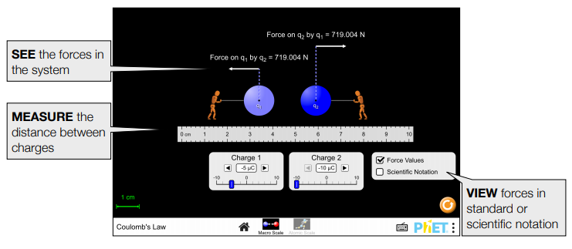
Familiarize yourself with the simulation. Play around with the settings, change the magnitude of the charges, the distance between the charges, and observe how the magnitude and direction of the force change. When you are finished testing all the settings, click on the orange reset button.
Step 1: Set change 1 to +4µC and charge 2 to +8µC. Set the distance “r” between the charges to 2 cm (by dragging one or both charges along the scale, e.g. if charge 1 is at 4 cm mark and charge 2 at 6 cm mark, the distance between them r = 2 cm = 0.02 m, remember 1 m = 100 cm). Record the magnitude of charges (in coulombs, remember that 1µC = 10⁻⁶C), the distance between them (in meters), and the magnitude of the force in the table on the next page.
Notice that the force of q₁ on q₂ is the same as that of q₂ on q₁. Also notice that the direction of the force in the simulation shows that the two charges repel each other (as you would expect since both the charges are positive).
Step 2: Keeping the charges fixed q₁ = 4µC and q₂ = 8 µC, change the distance between them to 3 cm or 0.03 m, record the force again in the table, along with the distance and magnitude of charges.
Step 3: Repeat step 2 for distances 4 cm, 5 cm, 6 cm, 7 cm, 8 cm, 9 cm and 10 cm. Record all the data in the table.
Charge q₁  (C) | Charge q₂  (C) | r  (m) | Force on q₁ by q₂  (N)
4 x 10⁻⁶ | 8 x 10⁻⁶ | 0.02 | 719
4 x 10⁻⁶ | 8 x 10⁻⁶ | 0.03 | 320
4 x 10⁻⁶ | 8 x 10⁻⁶ | 0.04 | 180
4 x 10⁻⁶ | 8 x 10⁻⁶ | 0.05 | 115
4 x 10⁻⁶ | 8 x 10⁻⁶ | 0.06 | 79.9
4 x 10⁻⁶ | 8 x 10⁻⁶ | 0.07 | 58.7
4 x 10⁻⁶ | 8 x 10⁻⁶ | 0.08 | 44.9
4 x 10⁻⁶ | 8 x 10⁻⁶ | 0.09 | 35.5
4 x 10⁻⁶ | 8 x 10⁻⁶ | 0.10 | 28.8

Step 4: Go to: https://mycurvefit.com/
On the top you will see plot, and below it you will see a data table. Click on the “Clear” link to the right of the data table to clear the data.
Step 5: Use your mouse to select only the data in the last two columns of your table above (starting from 0.02, not including the heading row that has r and Force on q₁ by q₂), copy this data. Paste this data into the data table by clicking in the table on your mycurvefit.com browser and pressing ctrl+v on the keyboard.
It will ask you: Is your data arranged by rows or by columns? Select “By Row” and click “Next”.
Then it will ask you: Which columns contains the X-axis data? Click on the left column and click “Next”.
Finally, it will ask you: Is this correct (with all the data displayed”? Click “Apply”.
Now you should see the graph created from your data.
Step 6: Click on the link “Fit Method” under the graph, from the drop down menu click on “Nonlinear” and then on “Power: y = ax^{b}”.
Now click anywhere outside the “Fit Method” menu. You will notice the fit parameters under your graph. The computer has fit your data to the function and : y = ax^{b} providing you all the fit paramters, like R²:1, aR²:1 etc.

Take a picture of your graph (or a screenshot) along with the fit parameters and paste it in the space below.

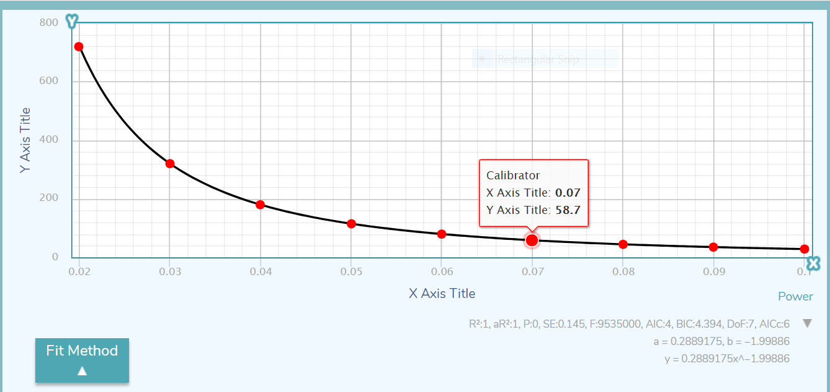

At this point we are only interested in the fit function that is given on the third line under the graph. It should be something like y = 0.1876238901x^-1.564321856. Write down this function in the space below:
y = 0.2889175x^-199886
What is the coefficient (experiment): a = 0.2889175
What is the power (experiment): b = -1.99886
In 1785, French physicist Charles-Augustin de Coulomb discovered that the force between two point like charged objects with charges q₁ and q₂ separated by a distance r is given by:
$$F=k\frac{q_{1}q_{2}}{r^{2}}$$
We call it Coulomb’s law.
In our fit above to the data that we collected; x represents r the distance. So, if you compare the fit function above to the Coulomb’s law, you should expect that:
The coefficient: a = $k_{e}q_{1}q_{2}$
And the power (theory): b = $-2.0$
Use the experimental value from your fit above and the actual value from theory to calculate the percent error. Show all your work below.
$$\% error= \left|\frac{b\left(theory\right)-b(experiment)}{b(theory)}\right| x 100$$
$$\% error= \left|\frac{-2.0- -1.99886)}{-2.0}\right| x 100$$

$\% error=$ ___0.057%___________
Now since: a = $kq_{1}q_{2}$ and you know the value of coefficient a from the fit above, and the charges are fixed throughout the experiment, i.e. q₁ = 4 x 10⁻⁶ C, and q₂ = 8 x 10⁻⁶ C, use all these values to find the value of the Coulomb’s constant k_{e}, using the equation below. Show all your work:
a = $kq_{1}q_{2}$

k (experiment) = $\frac{a}{q_1 q_2}$
= 0.2889175/ (4 x 10⁻⁶) x (8 x 10⁻⁶)
= 9.028 x 10⁹
Actual value of $k$is: k (actual) = 9 x 10⁹
Use the experimental value from your fit above and the actual value from theory to calculate the percent error. Show all your work below.
$$\% error= \left|\frac{k\left(actual\right)-k(experiment)}{k(atual)}\right| x 100$$
$$\% error= \left|\frac{(9 x {10}^{9})-(9,028,671,875)}{(9 x {10}^{9})}\right| x 100$$

$\% error=$ __0.319%____________

